徽标

**Second Labs on** **Real-Time Scheduling**

**Guohao DAI**

November 25th, 2022

**Exercise 1**

Let’s assume the following task sharing resources , and :

1. 图片包含 应用程序

   描述已自动生成The Simulation of this configuration without a specific protocol for resource allocation is ***not schedulable***. Because missed its deadline twice: (absolute deadline = 12; completion deadline = 17) and (absolute deadline = 32; completion deadline = 37).
2. 日程表

   中度可信度描述已自动生成The Simulation of this configuration with the Priority Inheritance protocol for resource allocation is ***not schedulable***. Because and both missed its deadline twice:

* : (absolute deadline = 12; completion deadline = 15) and (absolute deadline = 32; completion deadline = 35).
* : (absolute deadline = 15; completion deadline = 16) and (absolute deadline = 35; completion deadline = 36).

1. 图片包含 表格

   描述已自动生成 The Simulation of this configuration with the Stack-based Protocol (Immediate Ceiling Inheritance Protocol) for resource allocation ***is schedulable***.

**Exercice 2**

Let’s assume the following task sharing resources , , and :

* 表格

  描述已自动生成The Simulation of this task configuration is ***not schedulable*** because of every task’s WCET(capacity).

**Exercice 3**

1. 表格

   描述已自动生成Is the following task configuration schedulable on one processor with two cores using a fully global Rate Monotonic scheduler?

* 日程表

  描述已自动生成This task configuration schedulable on one processor with two cores is using a fully global Rate Monotonic scheduler: “No deadline missed in the computed scheduling: the task set is schedulable if we computed the scheduling on the feasibility interval. ”

1. 表格

   描述已自动生成Is the following task configuration schedulable on one processor with two cores using a fully global Rate Monotonic scheduler?

* The simulation of this configuration with the Priority Inheritance protocol is not schedulable, because missed its deadline three times: (absolute deadline = 12; completion deadline = 15), (absolute deadline = 24; completion deadline = 28) and (absolute deadline = 36; completion deadline = 43).

3． The conclusion is that if 2 tasks have the same periods and are synchronized, then for a dual-core processor, both cores will execute both tasks simultaneously. For the third task , it does not perform well. Compared to the second simulation, the first simulation performs task better.

**Exercice 4**

Let’s assume the following configuration of tasks.

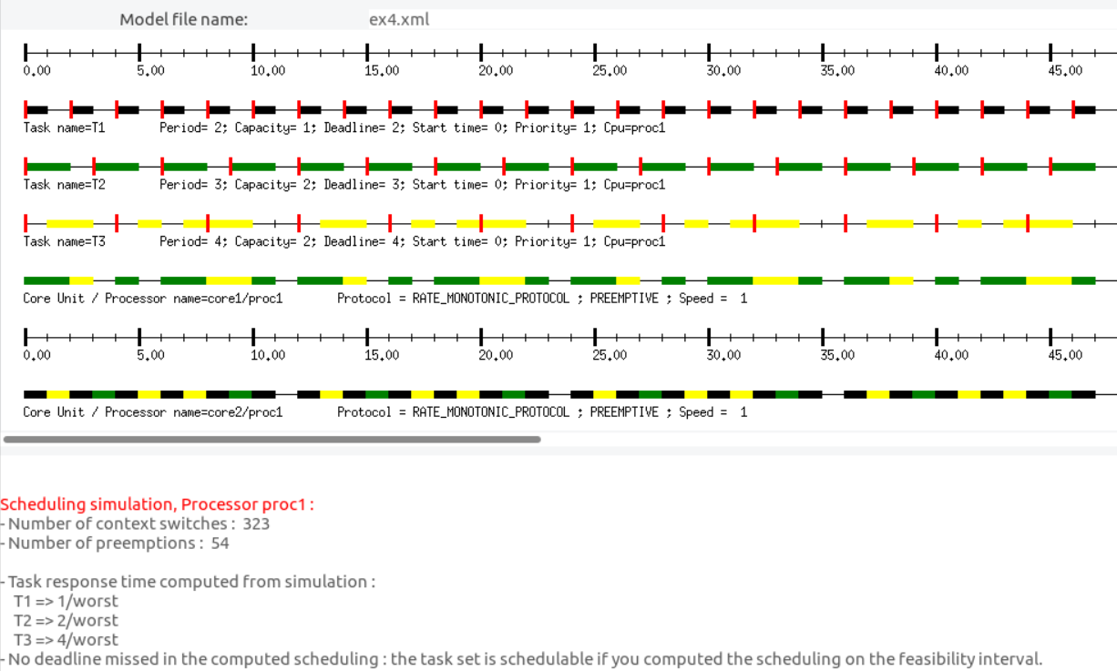

Exercice 5

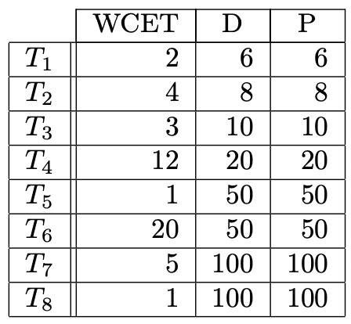Let’s assume the following configuration of tasks.

1. Is it schedulable on three processors with a partitioned First-Fit Rate Monotonic scheduler?
2. Same question with a partitioned First-Fit Earliest Deadline First scheduler.

**ANSWER:**

Firstly, we calculate the processor utilization rate of each task :

|  |  |  |  |  |  |
| --- | --- | --- | --- | --- | --- |
| Task 2 |  | Task 4 |  | Task 1 |  |
| Task 3 |  | Task 5 |  | Task 6 |  |
|  |  | Task 7 |  |  |  |
|  |  | Task 8 |  |  |  |
|  | |  | |  | |
| **Processor 1** | | **Processor 2** | | **Processor 3** | |

The tasks are **schedulable** on three processors with a partitioned First-Fit Rate Monotonic scheduler and First-Fit Earliest Deadline First scheduler.

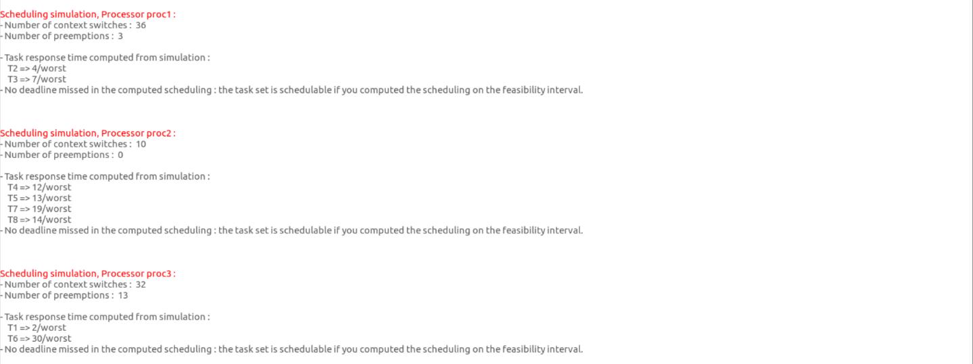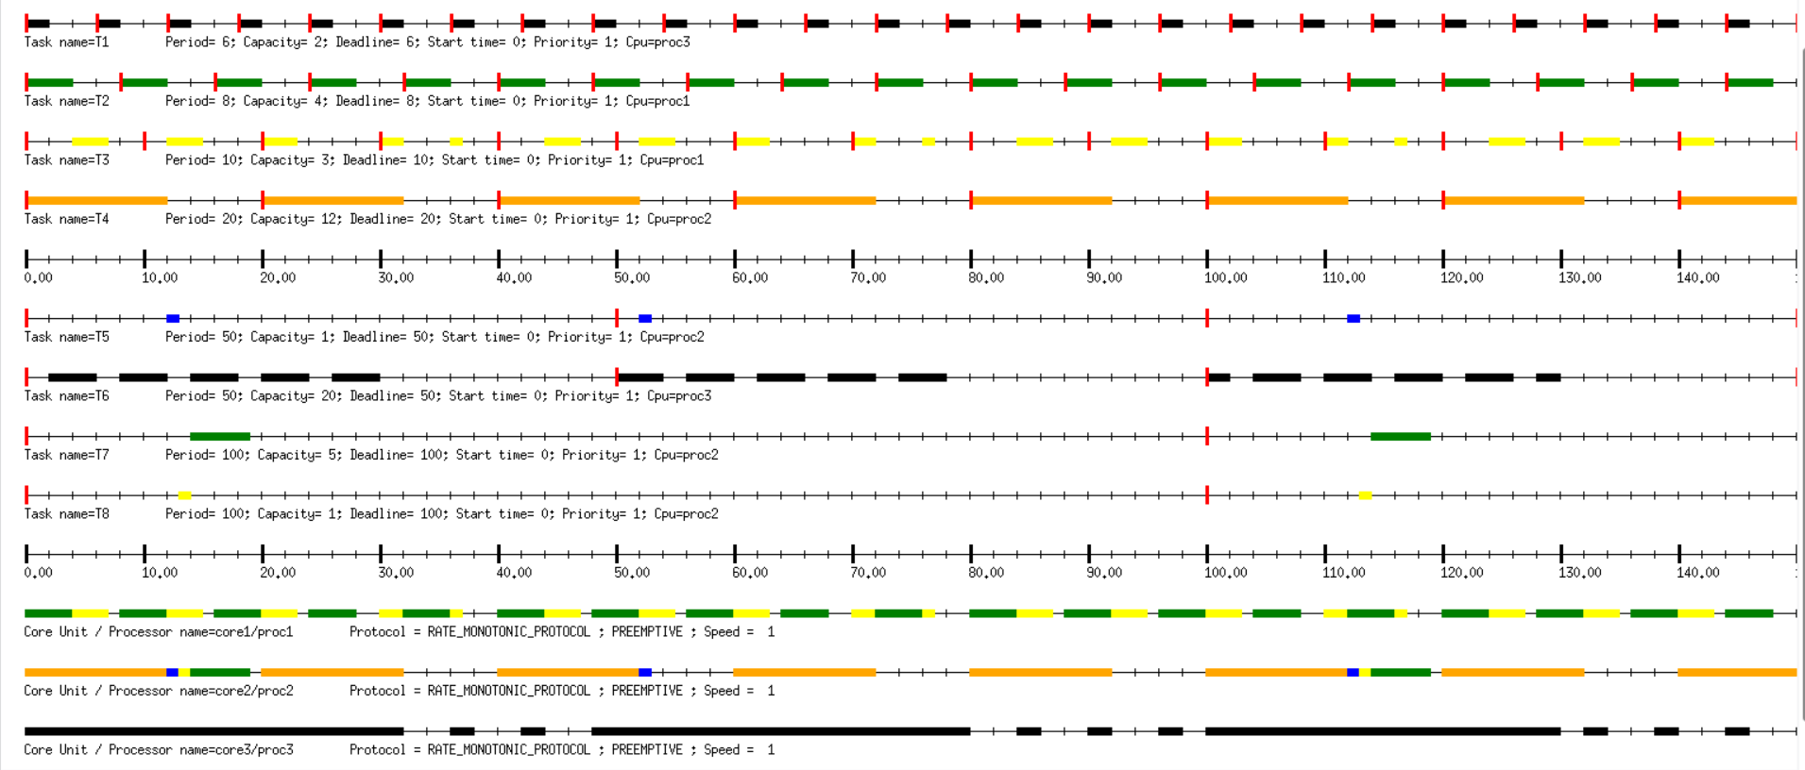First-Fit Rate Monotonic scheduler:

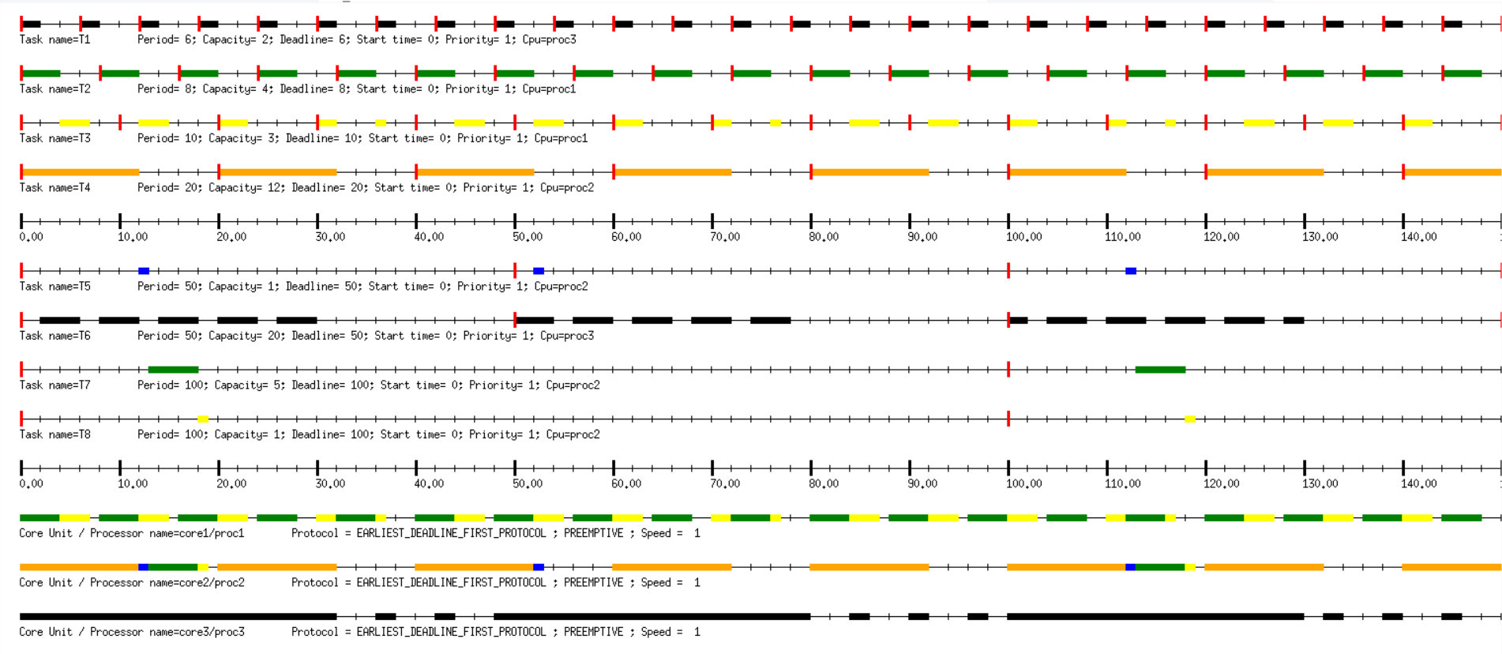First-Fit Earliest Deadline First scheduler:

